ARMY SQUASH TOUR
HONG KONG
OCTOBER 2014

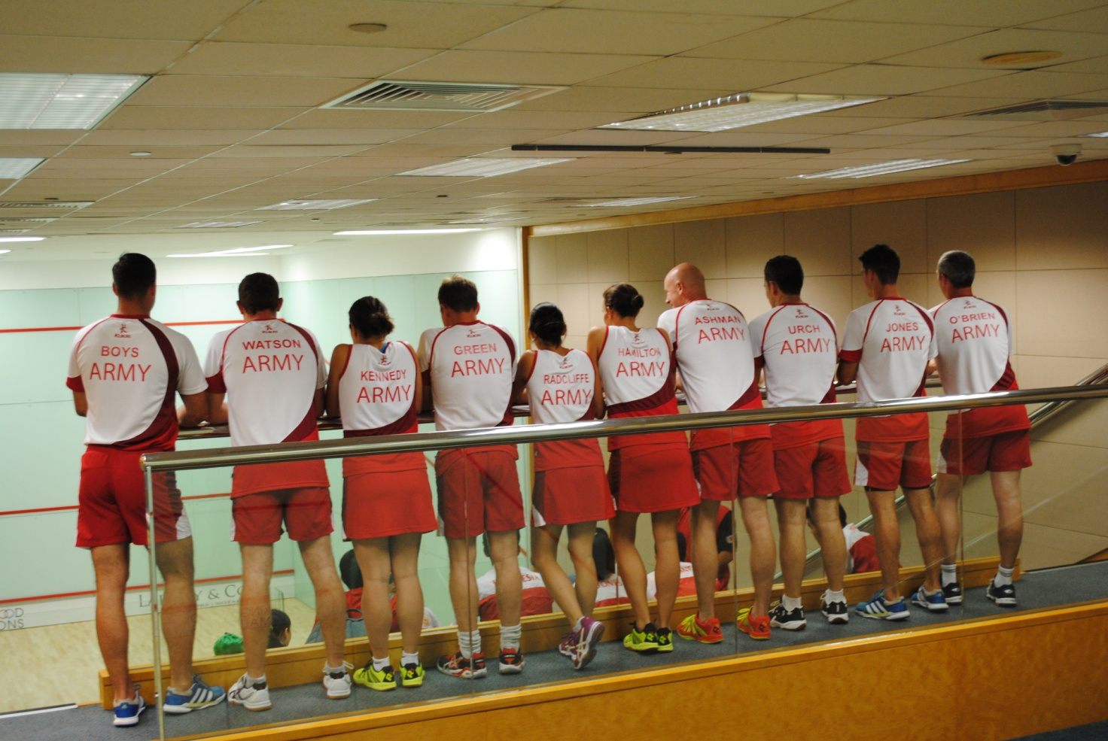

Above: Sgt D Boys, LCpl B Watson, Maj Y Kennedy, Maj R Green, Capt E Radcliffe, Lt R Hamilton,
Maj P Ashman, Maj Gen T Urch CBE, LCpl R Jones, Capt C O’Brien, (absent: Lt Col S White)

Foreword

The Army Squash tour to Hong Kong this year was an outstanding success. Thanks must go to Maj Yvette Kennedy as tour manager for putting together a competitive and full tour in under three months. The Army squad included 3 Men, 3 Ladies, 2 U25s and 3 Vets. An excellent team with strength throughout ensured that we would be competitive against our multiple opponents in a country where Squash excels.

The tour was ten days long with matches planned every day but one and training each morning where fixtures allowed. Coaching and training was led by Maj Rich Green and supported by Capt Elaine Radcliffe in her role as Physio. The tour was physically demanding but allowed the entire squad to develop and improve prior to the upcoming season. The opportunity to go up against world ranked players and the developing Indonesian national team was fantastic and will certainly have taught a number of lessons.

Our thanks must go to all those that made the tour possible; the Army Sports Lottery for providing essential funding, Commanding Officers for releasing the players and as always the constant support of Col Peter Sharland and Wendy Tapp at ASRA. We must also thank our in country sponsors who helped organise and run our fixtures; Steve Gollop and Chris Clark for all their supporting activity, the Hong Kong Football Club for the very kind use of all their facilities and all the clubs (Hong Kong Cricket Club, Kowloon Cricket Club, United Services Recreation Club and the American Club) for putting out competitive teams and their truly exceptional post match hosting.

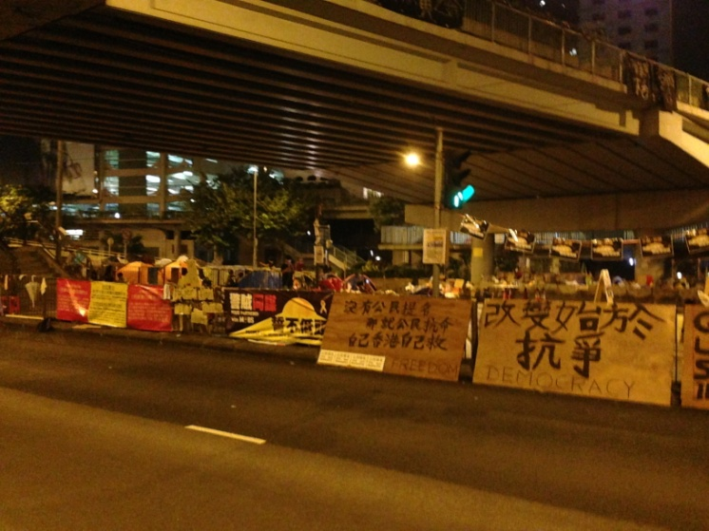
Day 1 – 3 October 14
The target time to meet at Heathrow was 1830 hours on a Friday afternoon. All braved the rush hour M25 traffic to meet at Terminal 3 in preparation to receive their new tour kit and bags from Lt Rosie Hamilton. For once all made it on time although some watch checking was required and ‘Fergie Time’ allowed for the Chairman (Lt Col Simon White).
Not knowing when we were going to eat next, everyone tucked into some airport food prior to boarding our flight. Everyone was excited in anticipation of the days to come and delighted to still be going with concerns about the ongoing protests in Hong Kong. With reports of police clashes only a few miles from our hotel and ongoing occupy protests calling for universal suffrage and the Chief Executive (CY Leung) to stand down, we were unsure whether the tour would be effected in any way.
Left: Occupy protesters camping out in Central.
Day 2 – 4 October 14
The team, having lost seven hours due to time zones, arrived at hotel at 1930 after an exhausting 14 hour flight. It was a quick wash and change for all before heading out for food where Capt Elaine Radcliffe’s fluent Cantonese ensured we weren’t eating chicken’s feet and cow’s intestine. It was then into Wan Chai to get a short taste of the cultural scene for those who hadn't been before. Everyone got safely back to the hotel for a long sleep in preparation for the start of a competition against Hong Kong Football Club and Indonesian national team the next day.
Day 3 – 5 October 14
Everyone headed to the Hong Kong Football Club, a short 5 minute walk from the hotel, where we were issued our temporary memberships and given a tour around the club by Steve Gollop. The temperature and humidity were immediately apparent to all and even the short walk caused sweating and the need to rehydrate.

A triangular competition had been organised to end up with a 1-16 ranking for the men and 1-14 for the ladies with 4 matches to be played by all. Two matches would be played today and the remaining matches on the 11th October. The competition had been organised by Chris Clark who has been a stalwart of squash in Hong Kong for many years.
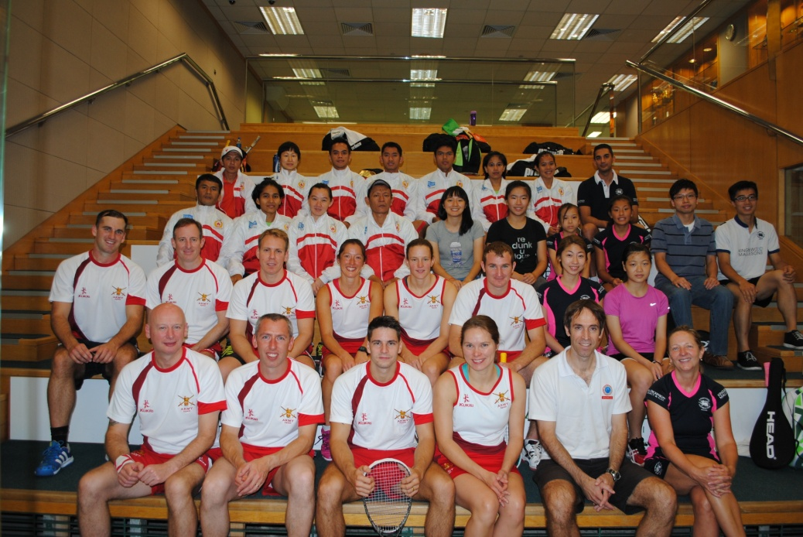
Left: Combined picture with Indonesian national team and members of HKFC
The first round only saw two victories for the Army; Maj Rich Green beating his opponent in 3 (Raj, his opponent, overheard saying it was a concern when fitness was an issue playing par to 11 and only 3 games). Lt Rosie Hamilton had a tight 4 setter against an 11 year old (Renee) from the Hong Kong Football Club who had her worried at times. Capt Elaine Radcliffe was the only other player to pick up a game in a tight fought contest. The remainder of the team was sent away to have words with themselves in the hope of better performances in the second round matches 2 hours later. Excuses of ‘Jet Lag’ and ‘acclimatisation’ were dismissed as weakness.

Round 1 Results:

Player 1 | Player 2 | Result | Score
Ho Fai Chiu (HKFC) | Simon White | Lost 3-0 | 11/4, 11/5, 11/4
Syauma Siswa (INA) | Dean Boys | Lost 3-0 | 11/4, 11/2, 11/5
Malcom Kerr (HKFC) | Chris O’Brien | Lost 3-0 | 11/8, 11/6, 11/5
Tim Fan (HKFC) | Rich Jones | Lost 3-0 | 11/5, 11/7, 11/9
Sandi Arishma (INA) | Phil Ashman | Lost 3-0 | 11/2, 11/2, 11/5
Adi Furkon (INA) | Barry Watson | Lost 3-0 | 11/1, 11/3, 11/6
Raj Nihalani (HKFC) | Rich Green | Won 3-0 | 7/11, 9/11, 6/11
Renee Wu (HKFC) | Rosie Hamilton | Won 3-1 | 9/11, 7/11, 11/7, 14/16
Anthea Yung (HKFC) | Yvette Kennedy | Lost 3-0 | 11/4, 11/2, 11/2
Kristy Chung (HKFC) | Elaine Radcliffe | Lost 3-1 | 11/6, 7/11, 11/9, 11/4
The second round saw more Army victories, but this was mainly the result of Army versus Army matches. Lt Rosie Hamilton had an exceptional result though, pulling a victory from the jaws of defeat against a strong Indonesian player.

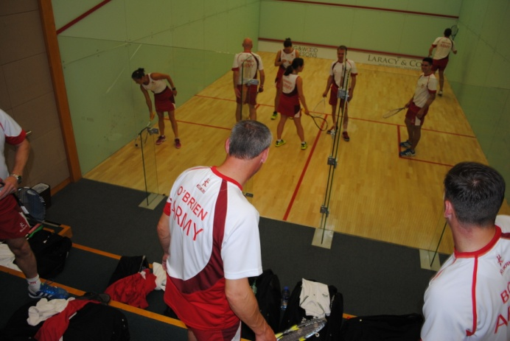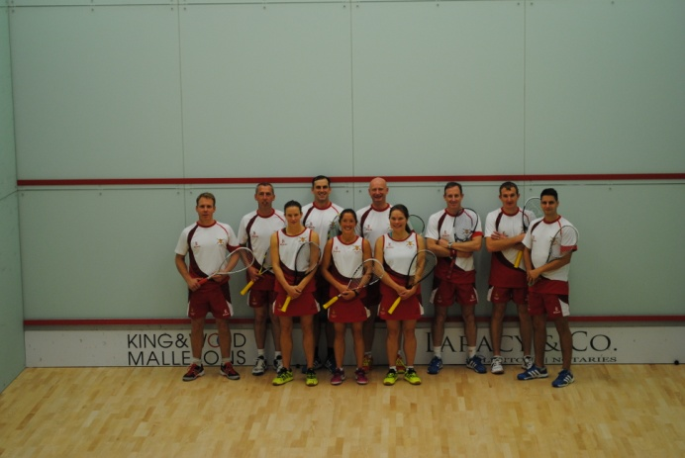
Left: Is this where we hit the rubber ball? Right: Fresh and ready for the first match.

Round 2 Results:
Player 1 | Player 2 | Result | Score
Adi Furkon (INA) | Rich Green | Lost 3-0 | 11/6, 11/0, 11/5
Simon White | Dean Boys | Won 3-0 | 7/11, 4/11, 8/11
Lincoln Chan (HKFC) | Chris O’Brien | Lost 3-0 | 11/9, 11/9, 11/4
Rich Jones | Phil Ashman | Lost 3-0 | 11/9, 11/6, 11/8
Raj Nihalani (HKFC) | Barry Watson | Won 3-0 | 7/11, 10/12, 8/11
Irma Maryaina (INA) | Rosie Hamilton | Won 3-2 | 11/7, 11/7, 7/11, 7/11, 7/11
Nicol Cheung (HKFC) | Yvette Kennedy | Lost 3-1 | 11/8, 6/11, 11/3, 11/8
Bye | Elaine Radcliffe | N/A | N/A
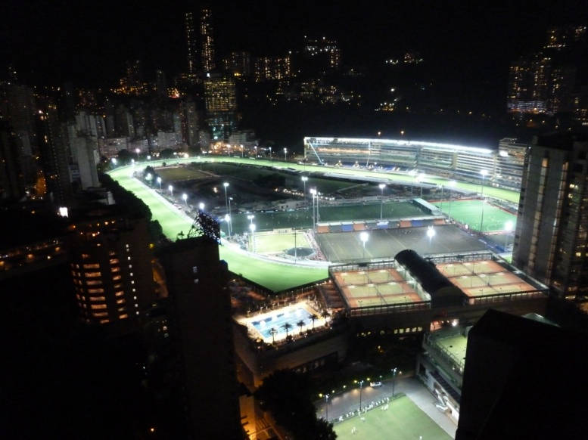
Post match was a little relaxation (food and drink) in the Sportsman’s Bar of the Hong Kong Football Club, located inside Happy Valley racecourse. Rendezvous at hotel was at 2000 hours before heading out for authentic Hong Kong meal at a Dai Pai Dong in North Point. A fantastic meal was enjoyed by all, although some struggled with the deep fried tofu and pig’s knuckles.
Left: Happy Valley Racecourse with HKFC tennis courts and swimming pool in the foreground.

Day 4 – 6 October 14
The first daily training session took place at Hong Kong Football Club at 1000 hours with the majority of the team looking fresh and in good order. Maj Rich Green put the team to work with some drills, whilst Capt Chris O’Brien and Lt Col Simon White had a quick play off to decide who would sit bottom seed for the men. Training complete, everyone headed in various directions. The majority headed to the pool to recuperate and clear the remnants of jet lag before the evenings match against the American Club.
We arrived early at the American Club, in Tai Tam just past Stanley, expecting the worst from HK rush hour. We were soon on court though. The early matches all went the Army's way with Capt Chris O’Brien, Maj Phil Ashman and Lt Col Simon White all taking 3-0 wins. Lt Col Simon White was glad to get a close encounter finished in 3 as the limited air con meant bouncy balls and long rallies. The evening continued to favour the team, victories continued for all except Maj Yvette Kennedy who fought hard against her male opponent, but went down 3-1 after a huge effort to win the third. It was then onto the number one seeds, LCpl Rich Jones versus one of the club pros, Patrick Choi. Some quality touches from both players saw Jones come out on top 3-1.
American Club | Army | Result | Score
Patrick Choi | Rich Jones | Won 3-1 | 15/13, 13/15, 7/15, 8/15
Gergoe S | Dean Boys | Won 3-0 | 14/16, 12/15, 9/15
Stephen Tsang | Rich Green | Won 3-1 | 11/15, 10/15, 16/14, 13/15
Greg Christison | Phil Ashman | Won 3-0 | 11/15, 9/15, 7/15
John Lau | Barry Watson | Won 3-0 | 2/15, 8/15, 8/15
Brock Williams | Chris O’Brien | Won 3-0 | 12/15, 7/15, 7/15
Bruno v de Schveren | Simon White | Won 3-0 | 13/15, 9/15, 17/19
Chipper Boulas | Rosie Hamilton | Won 3-0 | 7/15, 3/15, 5/15
Vivi Thomas | Elaine Radcliffe | Won 3-1 | 15/10, 10/15, 7/15, 15/17
Tom Burns | Yvette Kennedy | Lost 3-1 | 15/9, 15/12, 13/15, 15/7
Result: 9-1 Army

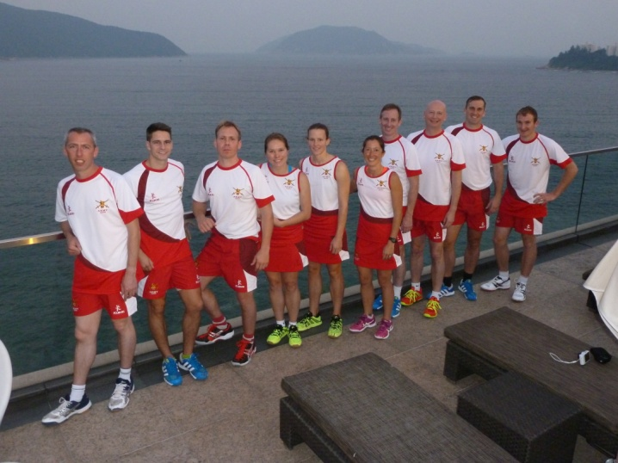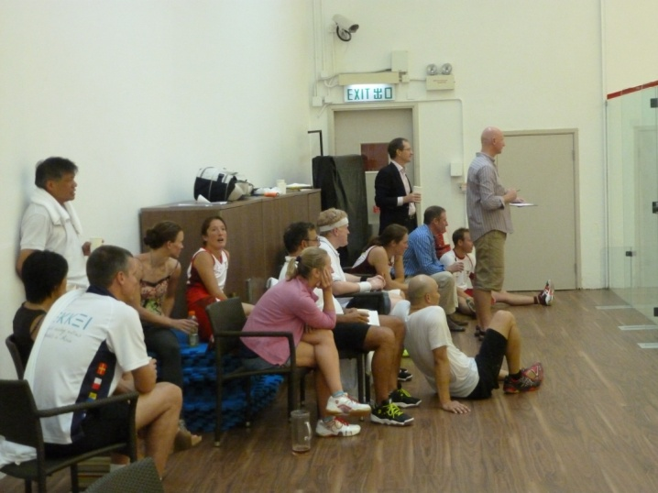
Left: South China Sea from the American Club. Right: Crowd drawn to watch LCpl Jones’ match.
We were exceptionally well hosted after the match at the club. Philly Cheesesteaks and American style burgers were enjoyed by all in excellent company.
Day 5 – 7 October 14
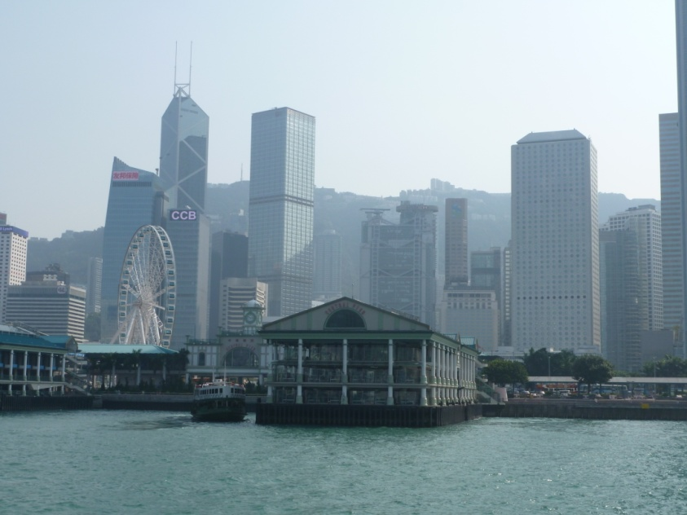
It was up and at it for a training session again at 1000hrs with some of the team already beginning to show a little wear and tear from the match the previous night. The afternoon was spent by most relaxing at the pool but a few braved the sights of Kowloon, travelling across the harbour on Star Ferry.
Right: Hong Kong Island from Star Ferry.
The evening’s match was at United Services Recreation Club a former Officers’ Mess Club from the colonial days. The match started with both Capt Elaine Radcliffe and Maj Yvette Kennedy losing 3-0 to their hard hitting male counterparts; a good effort from both. The next two matches were both hard affairs going the full distance. Lt Col Simon White overcame the trickery of his opponent to win 3-2 and Maj Phil Ashman fought back from 2-1 down to win a gruelling affair 14-12 in the fifth. LCpl Barry Watson and Lt Rosie Hamilton then came on to steady the ship with quality squash, both winning in 3. After a little break as we waited for the final players to finish work, Capt Chris O’Brien had a nick competition with his opponent after Fayyaz had the audacity to cross court volley nick him. He came out on top for the fifth Army win meaning we could no longer lose the match. It was then into the top three seeds. Sgt Dean Boys had a hard battle but came out on top 3-2, LCpl Rich Jones proved too fast for his opponent winning 3-0 whilst Maj Rich Green at 1 dropped a game on his way to a good victory.
USRC | Army | Result | Score
Vincent Wong | Rich Green | Won 3-1 | 10/12, 11/6, 7/11, 8/11
Wong King Yat | Rich Jones | Won 3-0 | 8/11, 8/11, 5/11
Tony Yip | Dean Boys | Won 3-2 | 6/11, 11/7, 3/11, 12/10, 5/11
Tim Mak | Phil Ashman | Won 3-2 | 5/11, 11/2, 12/10, 12/14, 12/14
Ray Man | Barry Watson | Won 3-0 | 5/11, 6/11, 10/12
Fayyaz Gull | Chris O’Brien | Won 3-0 | 11/13, 6/11, 2/11
Illyas Gull | Simon White | Won 3-2 | 6/11, 14/12, 11/5, 8/11, 6/11
Gary McAuslan | Rosie Hamilton | Won 3-0 | 5/11, 7/11, 6/11
Ken Yam | Elaine Radcliffe | Lost 3-0 | 11/9, 11/4, 11/9
Dale Hanson | Yvette Kennedy | Lost 3-0 | 11/6, 13/11, 11/3
Result: 8-2 Army

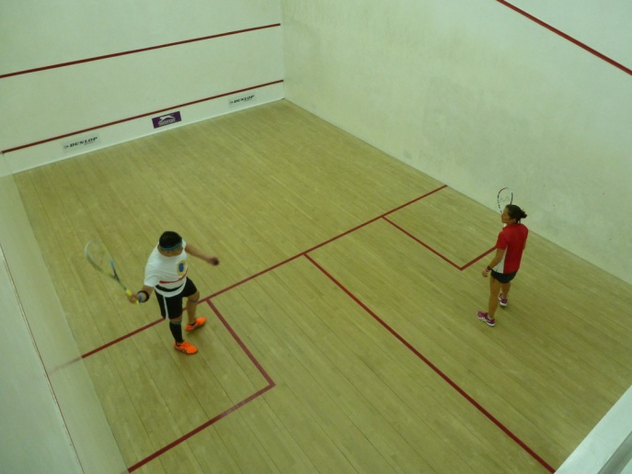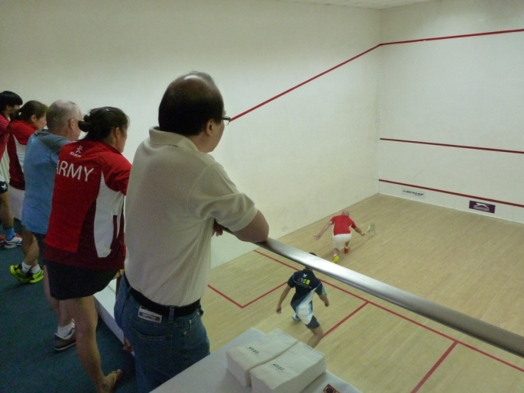
Right: Maj Ashman demonstrating the delicate art of a Vets lunge.
Left: Capt Radcliffe receiving against her heavily strapped opponent.

The United Services Recreation Club has a reputation for the best curries in Hong Kong and they didn’t disappoint. The spread was magnificent and after ensuring that we fully appreciated their excellent hospitality we headed on our way back to the Island via Temple Street Night Market.
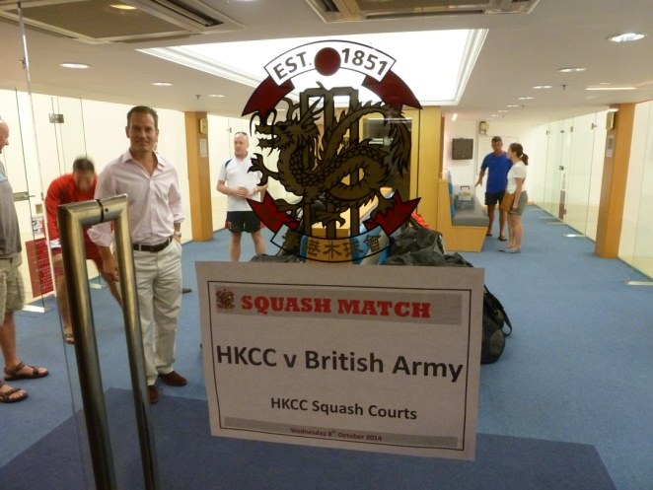
Day 6 – 8 October
The day started with a training session, as standard by now, at the HKFC. Capt Elaine Radcliffe gave a briefing on stretching and maintaining the body under the continuous stress of hard daily matches; probably needed as a few people were starting to get aches and pains. Maj Gen Urch arrived in the afternoon and was straight on court to brush off any cobwebs.
The evening’s match was against Hong Kong Cricket Club. Top seeds were on early playing Hong Kong and world ranked players. LCpl Rich Jones had an epic 3-2, playing stunning squash to win 12-10 in the fifth against a player currently ranked 7 in Hong Kong. Sgt Dean Boys was outclassed by the club pro (ex 74 world ranked) and lost in 3. Maj Rich Green put in a good effort to win a game against his excellent opponent who managed to pick up every shot possible and ranked 183 in the world. Maj Phil Ashman played well picking up his first game but was beaten in 4 by a very good opponent. Watson, O’Brien, White and Hamilton all picked up good 3-0 wins with both Watson and Hamilton sporting some of Elaine's taping handiwork to ensure niggles didn't turn into injuries. Maj Gen Ty Urch fought through jet lag to win 3-1, Capt Elaine Radcliffe fought hard to gain a game but succumbed 3-1 and Maj Yvette Kennedy lost in 3 against her strong opposition.
HKCC | Army | Result | Score
Wong Chi Him | Rich Green | Lost 3-1 | 11/8, 11/6, 3/11, 11/6
Mathew Ma | Rich Jones | Won 3-2 | 11/13, 11/3, 9/11, 11/2, 10/12
Dick Lau | Dean Boys | Lost 3-0 | 11/3, 11/4, 11/8
Dave Mallinson | Phil Ashman | Lost 3-1 | 15/12, 10/15, 17/15, 15/7
Liam | Barry Watson | Won 3-0 | 10/15, 6/15, 8/15
Matt King | Chris O’Brien | Won 3-0 | 10/15, 16/18, 9/15
David Winfield | Simon White | Won 3-0 | 10/15, 12/15, 10/15
Vishal | Rosie Hamilton | Won 3-0 | 8/15, 6/15, 11/15
Andy Burden | Tyrone Urch | Won 3-1 | 9/15, 15/13, 9/15, 9/15
David Hewitt | Elaine Radcliffe | Lost 3-1 | 13/15, 15/8, 15/6, 15/9
Donald | Yvette Kennedy | Lost 3-0 | 15/11, 15/1, 15/12
Result: 6-5 Army

Well hosted after match with stunning curries the team didn't get back to the hotel until gone midnight.
Day 7 – 9 October 14
Rest day finally! Much needed by all after 4 days of hard competitive squash. A Junk trip from Sai Kung out to the islands had been organised with all inclusive with drinks and food. The food was stunning and we were well looked after by the crew as soon as we were on board. Once we were anchored in sight of shore, Maj Rich Green led a swim to the beach. A bit of a struggle for the weaker swimmers but the return collection by boat was greatly appreciated. Water sports consisted of wake boarding, water skiing and banana boating which was participated in by the more energetic. Those less energetic resorted to falling gracefully or not from the top of the junk into the warm sea water.
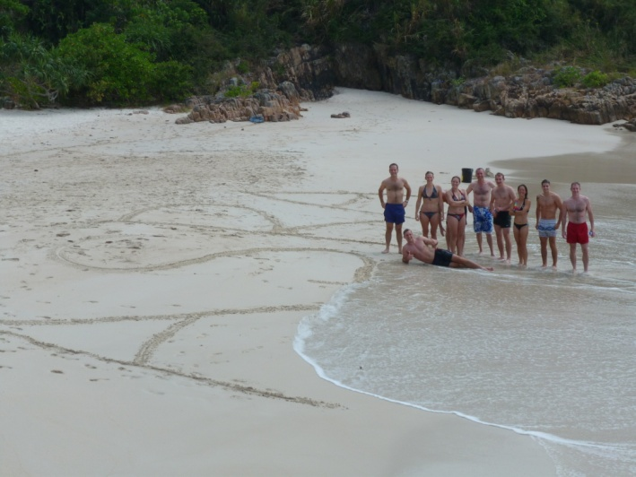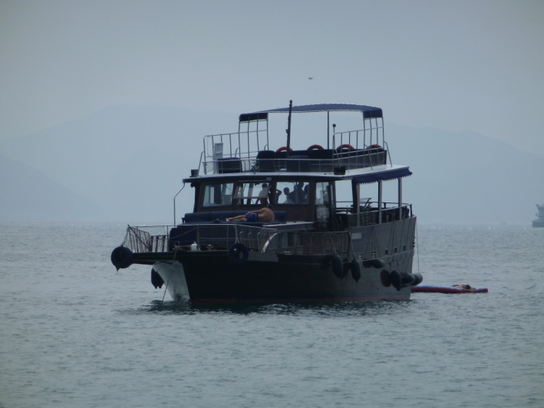
Left: The swimmers that made it. Right: Our transportation for the day.
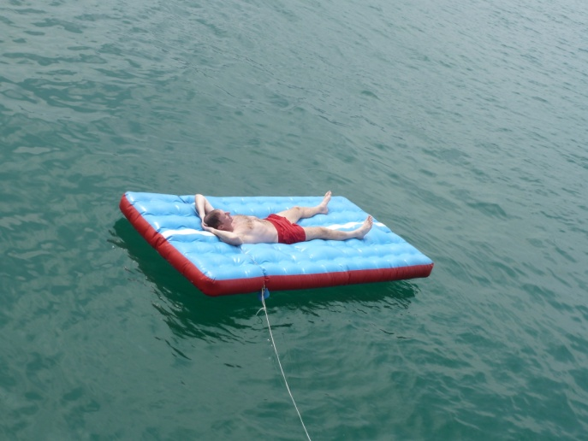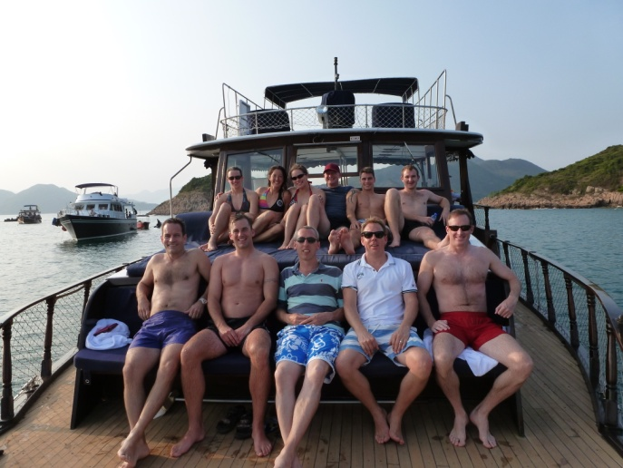
Left: Chairman enjoying a rest. Right: A motley crew.
By the time we were back on Hong Kong Island there was time for a swift visit to the pavilion bar of the Crowne Plaza hotel before dinner which allowed everyone to see the Hong Kong skyline by night from the 27th floor. It was then straight out to the American Peking restaurant in Wan Chai for the official tour meal where a thank you was said to those who had assisted Maj Yvette Kennedy is setting up the tour. A full Chinese meal was enjoyed by all including Peking duck and grouper. Well rested, but tired from a full day’s fresh air, the majority turned in for early nights.
Day 8 – 10 October 14
It was straight back to training after the day off; no rest for the wicked. A good session allowed everyone to get back into squash mode ready for the evenings match at Kowloon Cricket Club. Most spent the afternoon sightseeing with a group heading to the Ladies Market in Mong Kok and another heading to Stanley Market. All made it back in time for the Friday rush hour trip via the Mass Transit Railway (MTR) to Jordan. An experience few will forget.
LCpl Rich Jones unfortunately picked up an injury in his first game. He tried to run it off but succumbed 3-0. LCpl Barry Watson had a stunning 3-2 win coming back from 10-6 down in the fifth. The result may have been assisted by Maj Rich Green who was overheard saying “it's not very tight Barry is it” whilst supping his post match beverage. Maj Yvette Kennedy picked up her first win of tour but let herself down saying “I think I've pulled my front calf muscle” - most people would call this their shin. Maj Phil Ashman lost to a ladies player (Hong Kong No 4 and Semi Pro) who confidently stated she intended to be world champion one day. Other notable performances of the night were Lt Rosie Hamilton coming back from 2 down to win in 5 playing probably her best Army squash and Lt Col Simon White winning a Chairman’s match prior to running to catch his early flight home.
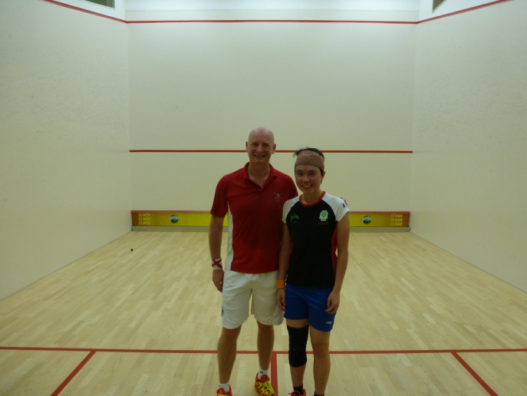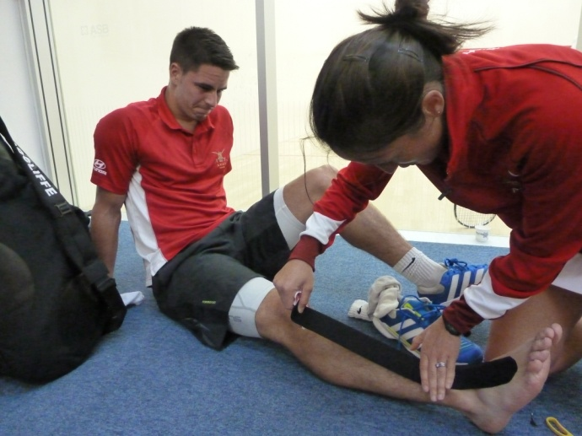
Left: Maj Ashman and Eunice Tong post match. Right: Physio skills required urgently.

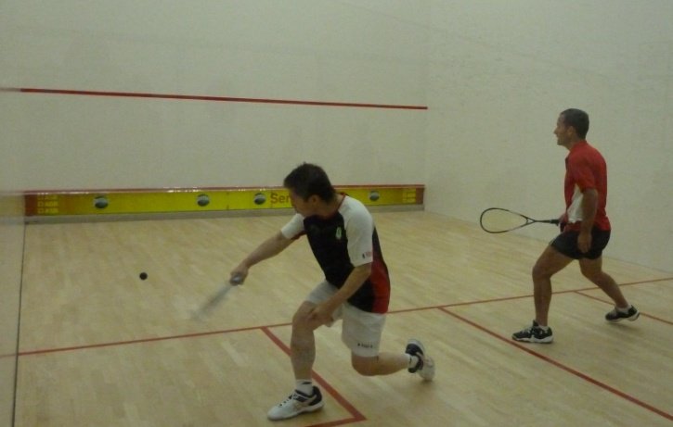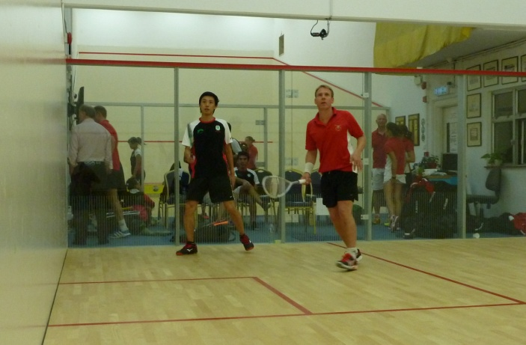
Left: Maj Gen Urch CBE battling Aaron Yip. Right: Maj Green warming up with Hugo Ho.

KCC | Army | Result | Score
Yeung Ho Wai | Rich Jones | Lost 3-0 | 11/7, 11/7, 11/4
Hugo Ho | Rich Green | Lost 3-0 | 11/5, 11/6, 12/10
Kenny Chu | Dean Boys | Won 3-1 | 11/6, 7/11, 4/11, 9/11
Bila Wan | Barry Watson | Won 3-2 | 8/11, 11/8, 11/7, 9/11, 11/13
S Chan | Chris O’Brien | Lost 3-1 | 7/11, 11/4, 11/9, 12/10
Aaron Yip | Tyrone Urch | Lost 3-1 | 11/6, 11/4, 10/12, 11/6
Eunice Tong | Phil Ashman | Lost 3-0 | 11/5, 11/5, 12/10
Ophelia Tsang | Rosie Hamilton | Won 3-2 | 11/8, 11/7, 3/11, 8/11, 5/11
Pinky Li | Elaine Radcliffe | Lost 3-0 | 11/1, 11/5, 11/7
Kat Labrum | Yvette Kennedy | Won 3-0 | 8/11, 9/11, 1/11
Evan Fowler | Simon White | Won 3-1 | 11/6, 4/11, 3/11, 4/11
Result: 6-5 KCC
Well hosted post match with a tasty buffet and great company. It was very interesting to meet Mike Dorrell whose grandfather, Lt Col George Thomas Dorrell, won a Victoria Cross at Néry in the First World War as a Battery Sergeant Major. It was back late again and a few decided to sample the delights of Lan Kwai Fong before hitting the sack.
Day 9 – 11 October 14
The final day of squash was to be the completion of the triangular against Indonesia and HKFC that was started on the 5th October. The first round kicked off at 1315 after numerous photo shoots. Notable results in the penultimate round were Lt Rosie Hamilton reaching the ladies final (1/2 play off) and Maj Rich Green making the 5/6 play off in the Men's. LCpl Rich Jones unfortunately had to withdraw again through injury so was unable to show the excellent form that has been notable throughout the tour.
Player 1 | Player 2 | Result | Score
Tim Fan (HKFC) | Rich Green | Won 3-2 | 9/11, 11/8, 8/11, 11/9, 7/11
Lincoln Chan (HKFC) | Dean Boys | Lost 3-2 | 11/3, 11/9, 2/11, 5/11, 11/5
Rich Jones | Barry Watson | Lost 3-1 | 11/5, 11/8, 7/11, 11/3
Tyrone Urch | Chris O’Brien | Won 3-0 | 8/11, 5/11, 7/11
Raj Nihalani (HKFC) | Phil Ashman | Won 3-0 | 8/11, 5/11, 4/11
Chan Ho Ching (SI) | Rosie Hamilton | Won 3-1 | 8/11, 7/11, 11/9, 6/11
Nicol Cheung (HKFC) | Elaine Radcliffe | Won 3-1 | 8/11, 11/8, 10/12, 4/11
Bye | Yvette Kennedy | N/A | N/A
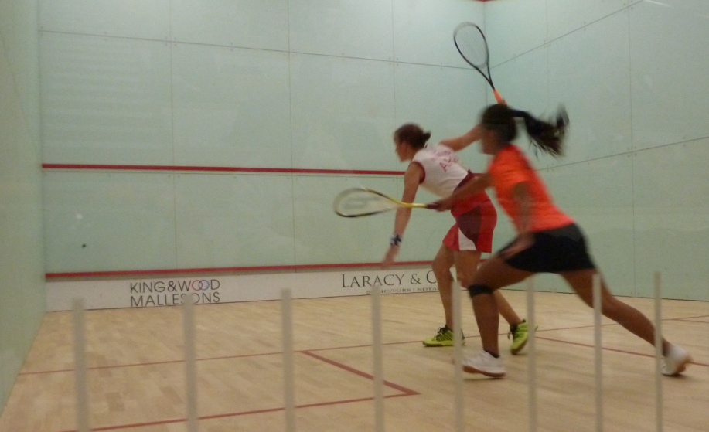
The final round saw Maj Yvette Kennedy win her playoff match to ensure she moved off the bottom in the ladies final positions; probably playing the best squash of her tour. The highlight for the Army though was the Ladies Final where Capt Rosie Hamilton was playing Gatur Yuliani from Indonesia. Rosie started strong and aggressive with length drives and tight drops earning her the first two games against a determined opponent. That determination showed throughout the remainder of the match as Rosie began to flag and a hard 3-2 the night before appeared to tell. The match became more scrappy and Gatur came back to win in five. An excellent match enjoyed by the large watching crowd. Maj Rich Green was unable to stand up to the quality of his Indonesian opponent in the Men’s draw losing 3-0, but took the accolade of the highest ranked Army player in 6th.

Left: Ladies Final - Lt Hamilton vs Gatur Yuliani.

Player 1 | Player 2 | Result | Score
Syauma Siswa (INA) | Rich Green | Lost 3-0 | 11/5, 11/2, 11/8
Lincoln Chan (HKFC) | Rich Jones | W/O | Jones Retired Injured
Dean Boys | Barry Watson | Lost 3-0 | 11/7, 11/9, 11/3
Chris O’Brien | Phil Ashman | Won 3-1 | 12/10, 10/12, 7/11, 7/11
Raj Nihalani (HKFC) | Tyrone Urch | Lost 3-0 | 11/7, 11/7, 12/10
Gatur Yuliani (INA) | Rosie Hamilton | Lost 3-2 | 11/13, 5/11, 12/10, 11/8, 11/5
Renee Wu (HKFC) | Elaine Radcliffe | Lost 3-0 | 11/6, 11/8, 11/3
Ursula Sze (HKFC) | Yvette Kennedy | Won 3-1 | 5/11, 6/11, 11/7, 4/11

Final Seedings:

Position | Mens | Ladies
1 | Ho Fai Chiu (HKFC) | Gatur Yuliani (INA)
2 | Adi Furkon (INA) | Rosie Hamilton (Army)
3 | Sandi Arishma (INA) | Chan Ho Ching (SI)
4 | Eris Setiawan (INA) | Yessy Gitawati (INA)
5 | Syauma Siswa (INA) | Irma Maryaina (INA)
6 | Rich Green (Army) | Anthea Yung (HKFC)
7 | Malcom Kerr (HKFC) | Paulina Radus (INA)
8 | Tim Fan (HKFC) | Kristy Chung (HKFC)
9 | Lincoln Chan (HKFC) | Renee Wu (HKFC)
10 | Rich Jones (Army) | Elaine Radcliffe (Army)
11 | Dean Boys (Army) | Nicol Cheung (HKFC)
12 | Barry Watson (Army) | Vivi Sclosser (HKFC)
13 | Phil Ashman (Army) | Yvette Kennedy (Army)
14 | Chris O’Brien (Army) | Ursula Sze (HKFC)
15 | Raj Nihalani (HKFC)
16 | Simon White/Tyrone Urch (Army)

Tournament over and the squash finished for the tour, the players from all 3 teams relaxed in the hospitality provided by the HKFC with an excellent buffet dinner on the terrace outside.

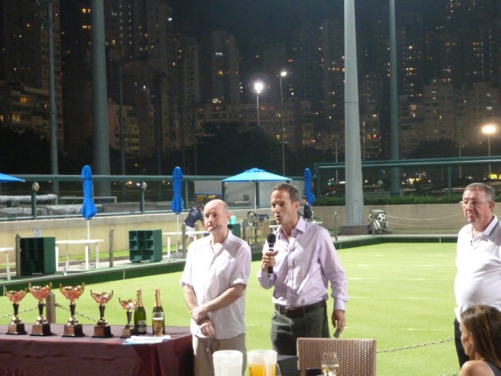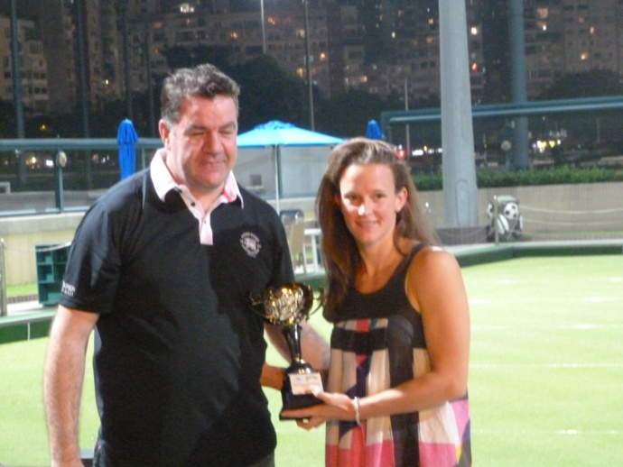
Left: When does the karaoke start? Right: Lt Hamilton presented trophy as Runner Up.

Day 10 – 12 October

A free day for all the players to do any shopping and sightseeing they hadn't been able to over the course of the tour. One group managed to get to the peak to see the views of the City from its highest point; others spent their last currency at Stanley Market whilst a few caught up with Family and Friends living in Hong Kong.

It was then a wave good bye to Hong Kong and off to the airport for the 13 hour flight back to the United Kingdom.

Summary

An excellent and well organised tour with lots of quality squash, both training and matches. It provided the opportunity for the whole team to improve and test their squash against a vast variety of fit and technical squash players. Not only was the squash challenging but the conditions - 30 degrees and high humidity - added another dimension to consider. Yet again Hong Kong delivered!

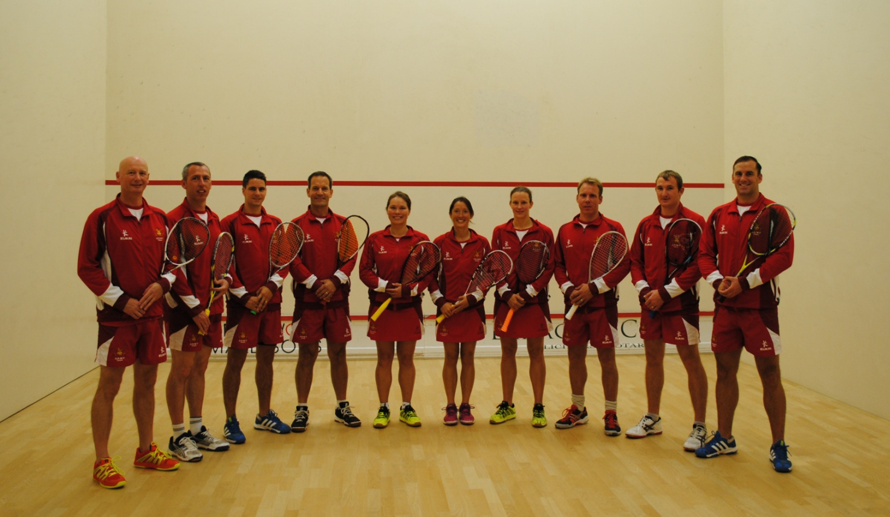
Above: Maj P Ashman, Capt C O'Brien, LCpl R Jones, Maj Gen T Urch CBE, Maj Y Kennedy,
Capt E Radcliffe, Lt R Hamilton, Maj R Green, LCpl B Watson, Sgt D Boys, (absent: Lt Col S White)

